Program location: [\\cscharkemafs01\Programs\Research Standing Frame\Research Standing Frame V2.0\research standing frame data processor V1.0](file:///\\cscharkemafs01\Programs\Research%20Standing%20Frame\Research%20Standing%20Frame%20V2.0\research%20standing%20frame%20data%20processor%20V1.0)

This program will calculate the force plate COP if the force plate is checked. The processed data is ready for FNS file combine. There is no need to use the old COPcal.m script.

1. Copy the folder to C:\
2. Open ‘StandingFrameDataProcessor.m’ and run it. You will see the following interface

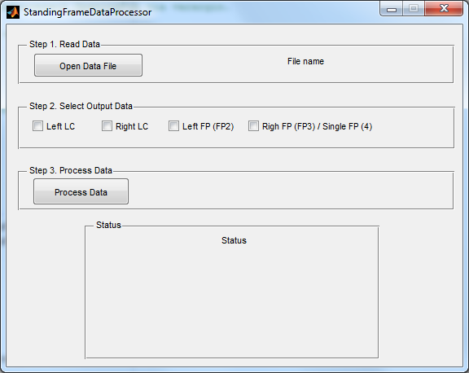

1. Open data file
2. Select the output data
3. Process the data and save it

You can use the test data (StandingFrameNewton-GUItest.dat) in the folder to test the program.